
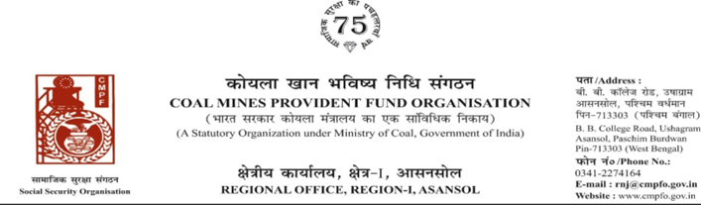
Ref. : CPF/118/Misc/LC OUT/R-I/ASN/ Date :07/08/2025

To,
The Regional Commissioner
Coal Mines Provident Fund
Unit No-F1 CSC No-2 Block G
Preet Vihar
Delhi 110092

Sub:- Inter Regional Transfer of Ledger Card.
Ref:-CPF/DEL/1/Misc/L.C.Transfer/513 dated 02/11/2023
Sir,
In view of the revised Procedures prescribed in Procedure Office Order No-35 Dated-12.02.1975 of CMPF Commissioner,Dhanbad, I am to state that the Ledger Cards of the following members is hereby forwarded to your Regional Office. Further, it is informed that the Form A & P.S.-3 & P.S.-4 forms are not available in this region.
It has been ensured that the posting in the Ledger Cards have been made/updated for the periods the member was working in this Region.

SL. No | Name of the Member | CMPF A/C No | Name of the colliery where the member had earlier worked in | Name of the colliery where the member is currently working in
1 | SRI AJAY KUMAR | RNJ/1/0197 | PANDAVESWAR REA (RNJ/1) | CIL DEL/1

Please acknowledge the receipt of the above at the earliest.
Yours faithfully

Encl. : Original LC (Two Nos) Assistant Commissioner

